START

1. Sql基础篇

数据库操作语言：DML select insert update delete merge

数据库定义语言：DDL create alter drop truncate

事务控制语言: TCL (transaction control language) commit rollback savepoint

数据控制语言： DCL（data control）grant revoke

1. 数据类型

Char varchar2 number date timestamp clob blob

1. 常用转换 date char number 三者类型经常转换

select TO_DATE('2015-08-19','YYYY-MM-DD') AS A_DAY FROM DUAL;

SELECT TO_CHAR(SYSDATE,'YYYY-MM-DD') AS TODAY FROM DUAL;

SELECT TO_TIMESTAMP('2015-08-19 17:40:32.11','YYYY-MM-DD HH24:MI:SS.FF') AS A_DAY FROM DUAL;

SELECT TO_NUMBER(REPLACE(TO_CHAR(SYSDATE,'YYYY-MM-DD'),'-')) FROM DUAL;

SELECT 1+1 AS RESULT FROM DUAL;

1. 常用sql语句

select deptno,decode(deptno,10,'部门1',20,'部门2',30,'部门3') from EMP;

select deptno,case when deptno = 10 then '部门1' when deptno = 20 then '部门2' else '部门3' END FROM EMP;

1. 分组 组函数：sum min max avg count

Group by … having 根据一个或者多个列对结果进行分组

查询每个部门的平均薪水之后显示部门平均薪水大于2000的部门编号和其平均薪水

Select DEPTNO,AVG(SAL) AS TEST FROM EMP GROUP BY DEPTNO HAVING AVG(SAL) > 2000

SELECT DEPTNO,SUM(SAL),AVG(SAL) FROM EMP group by DEPTNO

1. 集合查询

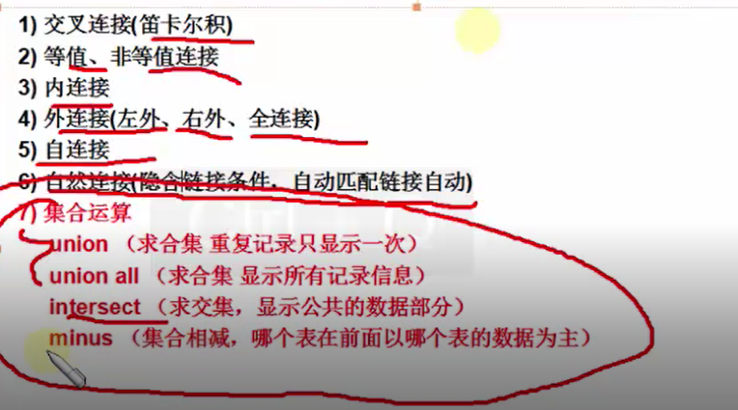

子查询

非关联子查询

关联子查询